InTime
Contractor Guide

Contents
Your self-service portal 2
Accessing InTime 2
Your homepage 2
Your dashboard 3
Timesheet and expenses basics 4
Entering your timesheet 4
Draft timesheets 5
Submitted timesheets 5
Entering expenses 5
Submitting expenses 6
Invoice and billing…………………………………………………………………………………………………………………...6
Contract documents………………………………………………………………………………………………………………...8
Viewing profile information…………………………………………………………………………………………………………8

Your self-service portal
In addition to submitting timesheets and expenses, you have access to the following functions:
- All placement information including related contract documentation, information requests and AWR status
- Your profile information, including the ability to update your personal information.
- Reporting of historical placement data.
- Viewing individual timesheet history.
- Action agency information requests, acceptance of contract and compliance documentation and/or submit queries using the comments feature.
- Viewing and printing payslips, self-bill invoices or advice notes and remittances.
- If you are a Limited Company contractor, the uploading of your supplier invoices against advice notes.
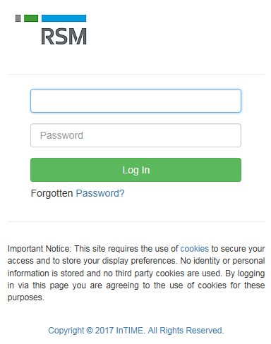Your homepage.

Accessing InTime
To get started with InTime, use the URL provided by your
agency administrator. You will be prompted for your username
and password, which will have been generated and sent to you
directly from the InTime system or via your agency administrator.

.

Once you have logged in you will be presented with the main InTime homepage.
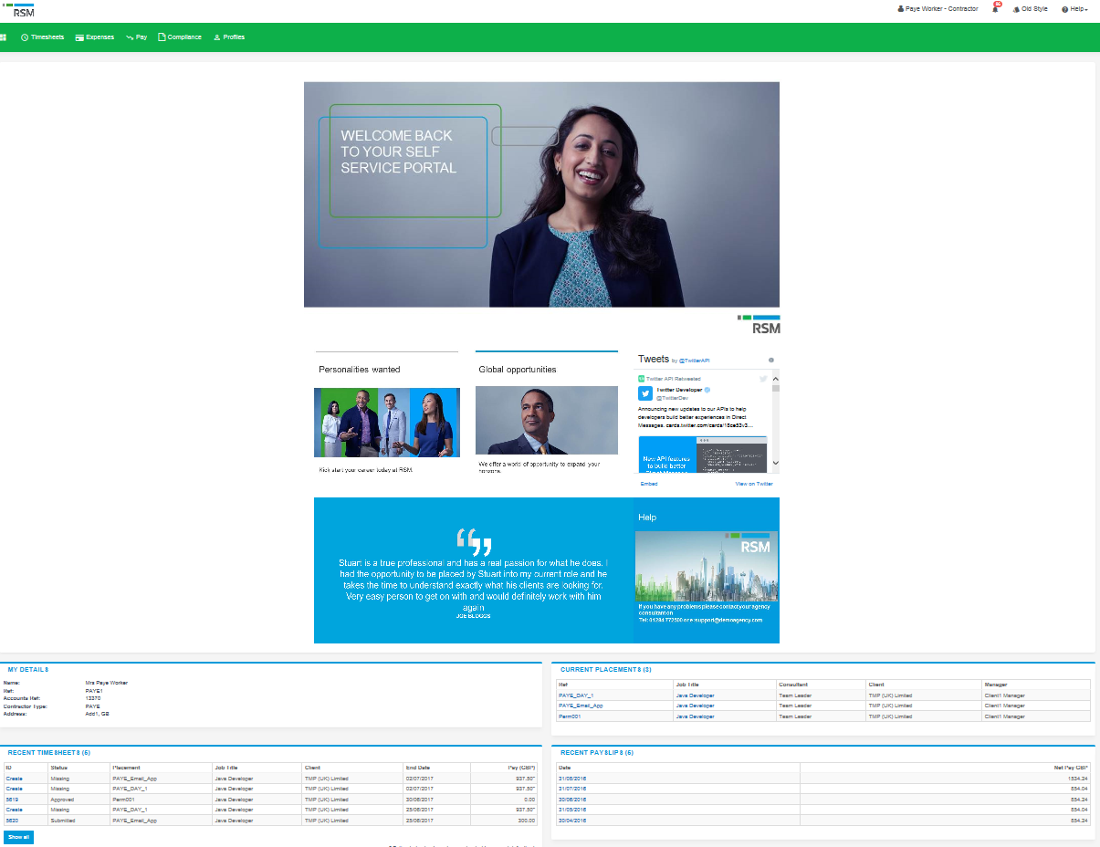
The navigation menu is located across the top of the page. Please be aware that the list of items in the menu bar can
vary depending on your agency’s requirements.

The menu bar options will include the following as shown above:
- A multi square icon – taking you back to your homepage.
- Timesheets – this provides access to new, draft and previously submitted timesheets, and a timesheet
search function.
- Expenses – which allows you to submit new and access historical expense claims.
- Pay – provides ability to access invoices and credit notes.
- Compliance – to facilitate information requests and submit documentation.
- Profiles – this gives details of your placements and associated clients.

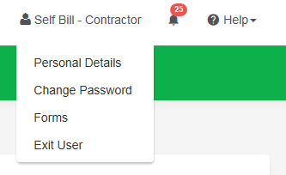
In the top right hand corner of your screen
- Your name – Click on this, options appear for you to:
  - Update your personal details.
  - Change password.
  - Request forms for holidays and address changes.
  - Exit InTime
- Bell Symbol – Advises you of notifications.
- Help – takes you to our on line documentation help bank.
.

Your dashboard
As you scroll down your homepage, your personal dashboard will provide you with a real-time status of your current
placement information, timesheets, expenses, and contract documentation that you can easily access directly from the dashboard.
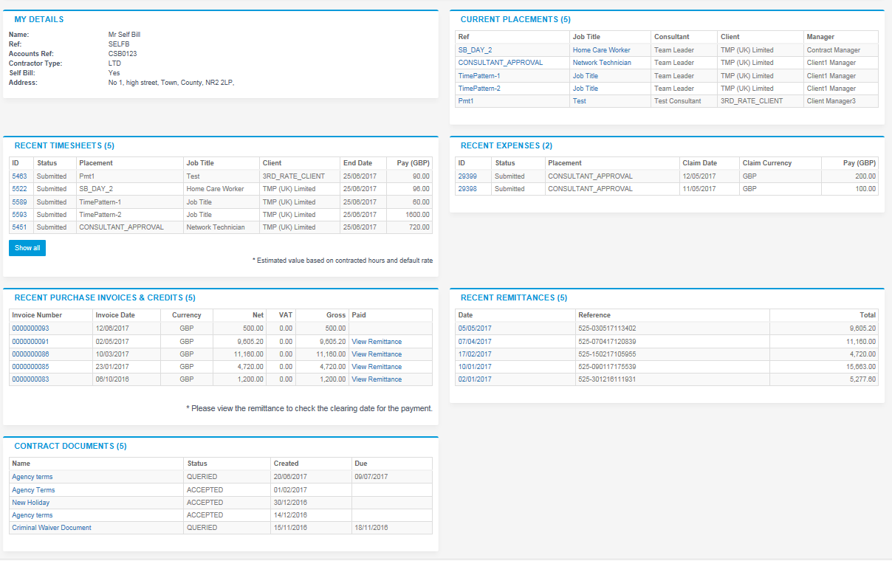

Timesheet and expense basics
Statuses of timesheets and expense claims explained:
Missing: Timesheets that should be received during a specified date range but have not yet been created.
Draft: Saved but not yet submitted. There are no draft expenses.
Submitted: Created and submitted for approval. Submitted timesheets and expenses cannot be modified so please ensure the details are correct before submitting.
Approved: Approved by your manager for payment.
Rejected: Rejected by your manager. This is usually because of incorrect hours or expense lines. The manager may have provided a comment as to why the timesheet or expenses was rejected. Once rejected, the timesheet becomes a draft for editing and resubmitting. Expenses can be edited via the expenses Rejected menu option

Entering your timesheet
To begin, hover over Timesheets from the main menu bar at the top of the screen and select Create.
You will then be prompted to select the placement from the drop down box to enter time against, as well as the
week ending date. You can use the provided calendar popup to help you select the correct date.
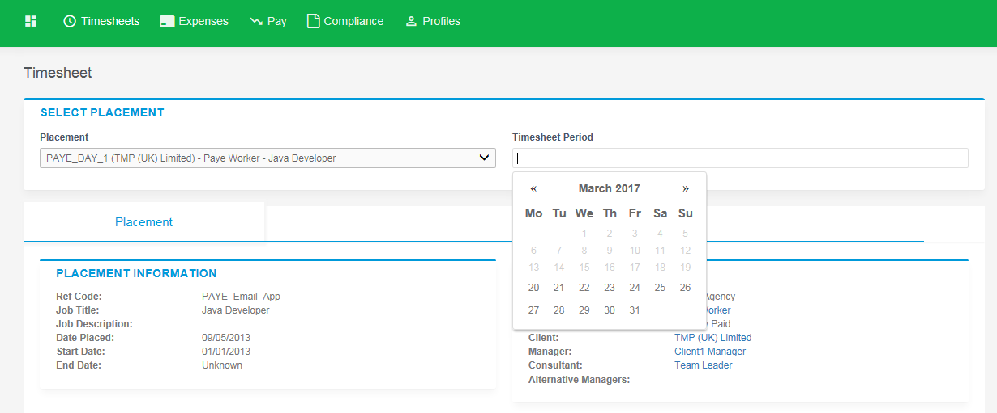
After selecting the period you will be presented with a blank timesheet form similar to the screen shot shown below: Enter Hours/Units/Time as applicable for the period selected. The basic rate is selected by default here, so you can start entering your time for each of the days. The total hours (or hours claimed) is calculated automatically.

If you require additional rates, click on the green plus to add a shift and select the appropriate item from the additional rate drop-down.
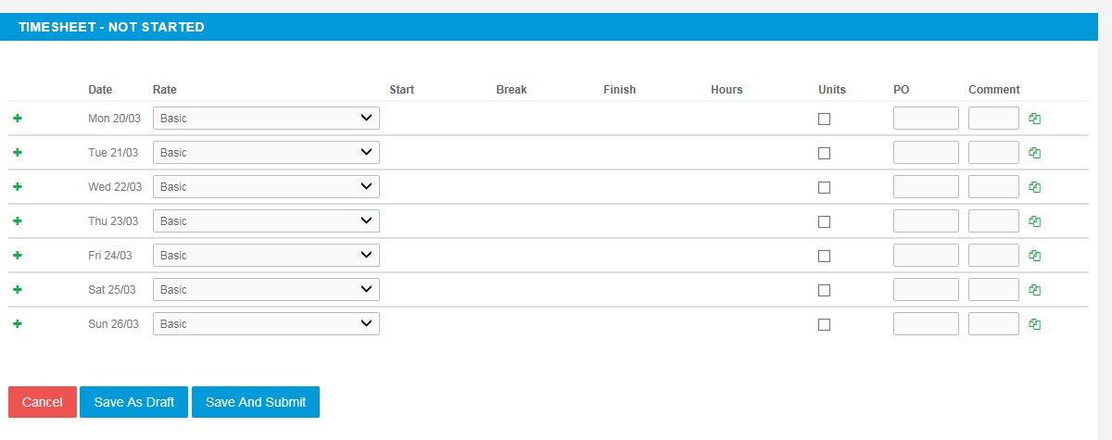
You can click on Save As Draft to store the timesheet which will allow you to return to this information to edit.

Once you have completed your timesheet click on the Save And Submit button, your timesheet will be sent to your Manager for approval. Please note: You will not be able to make any further edits once the timesheet has been submitted for approval.

Draft timesheets
If you have created timesheets and saved them previously without submitting, you can still access them by selecting Drafts from the Timesheet menu, or from your dashboard. You will then be taken to the timesheet form described in the Entering your timesheet section. Please refer to these instructions to edit and submit your draft timesheet.
Image 5

If you have multiple draft timesheets you wish to submit for approval, tick the box in the Submit column against the applicable timesheet and click on Submit. If you need to access a specific timesheet, click on the number in the ID column to view, edit, or submit.
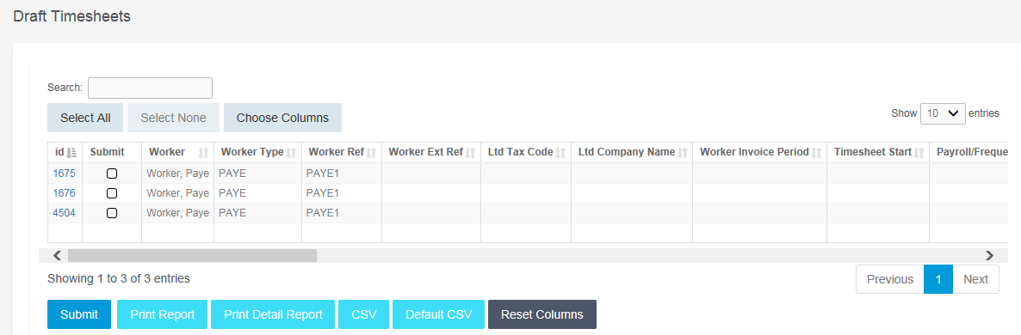Submitted timesheets
If you need to check the status of your submitted timesheets, you can use your dashboard and see the status, or use the Unauthorised, Approved or Rejected options from the Timesheets menu.
By clicking the timesheet ID you can also see a detailed view of that timesheet. Note that you can only modify rejected timesheets.

Entering your expenses
Go to the expenses menu at the top of the screen and hit create, you will then be prompted to select the client and placement you wish to claim against. You will now be presented with a blank expenses claim form.
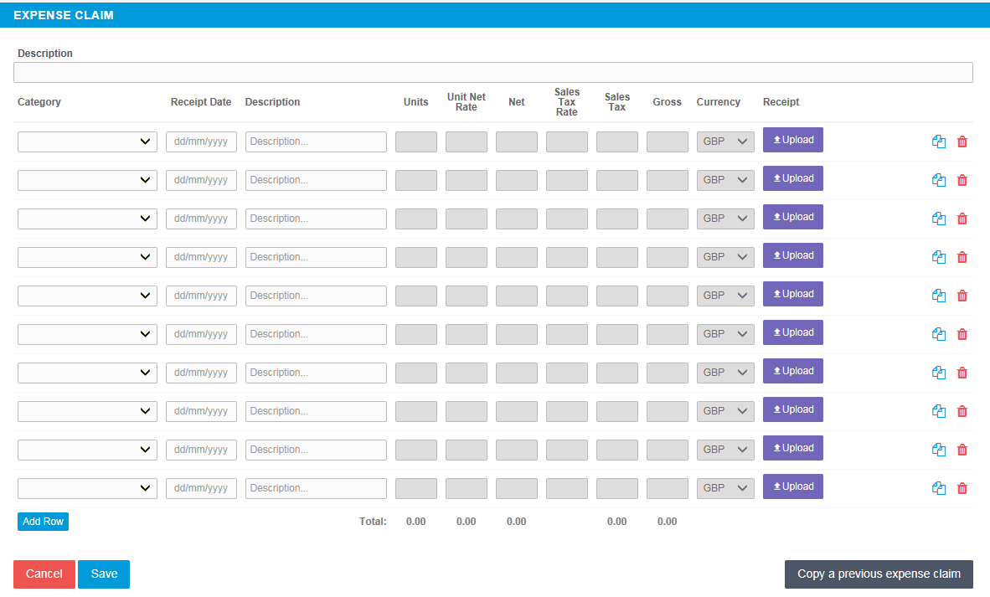

Select the correct type of expense and description from the provided dropdowns. Once you have filled in all the required fields hit save. You will then get a summary of your expenses. If you need to edit your claim please click the Edit button option. Once you have finished your claim, click Submit.

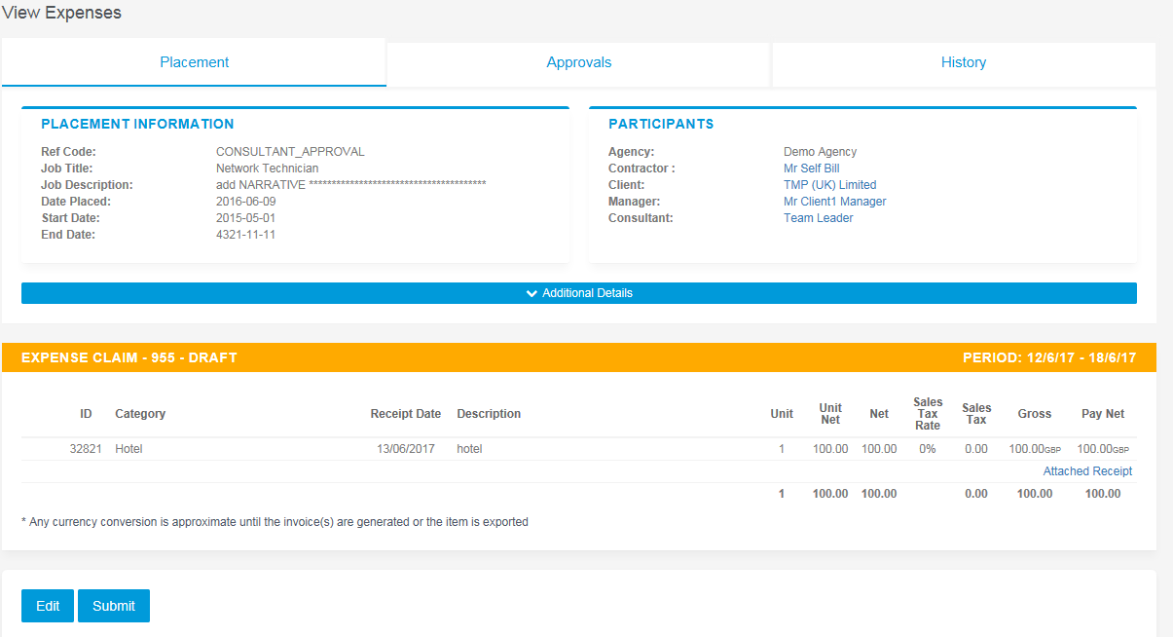

Submitted expenses
Image 6
If you need to check details of your submitted expense claim, or to see if your manager has approved them, click Unauthorised, Approved or Rejected on the Expenses menu.

You can now view the status and summary of your submitted expense claim. By clicking the relevant expense item you will be able to see a detailed view of the expense. Note that you will only be able to modify rejected expense claims.
Image 7

Invoice and billing
If you are a Limited Company contractor and don’t have a self-bill agreement in place, you will receive an Advice Note from the agency. The advice note will contain all the details needed to create an invoice. Typically, it will contain timesheet details and expense claims.

From the menu bar, select Pay and then List Advice Note.
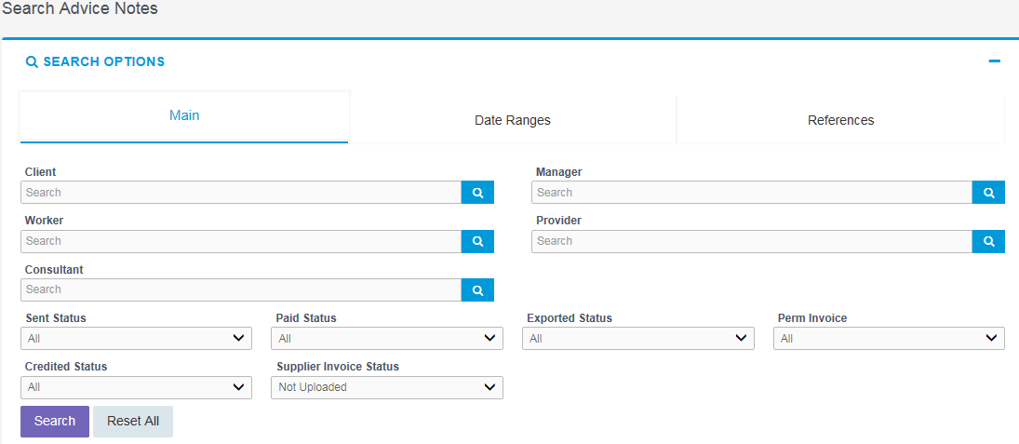
Use the filters to search for advice notes waiting for you to create an invoice against. For example, by leaving the filters at their defaults and selecting Search, the system will return all advice notes; or you could search for just the advice notes that do not have an uploaded invoice against them by selecting Supplier Invoice status: Not Uploaded.
In the list of advice notes, scroll along until you see the invoice document column click Upload to upload an invoice to match the advice note.
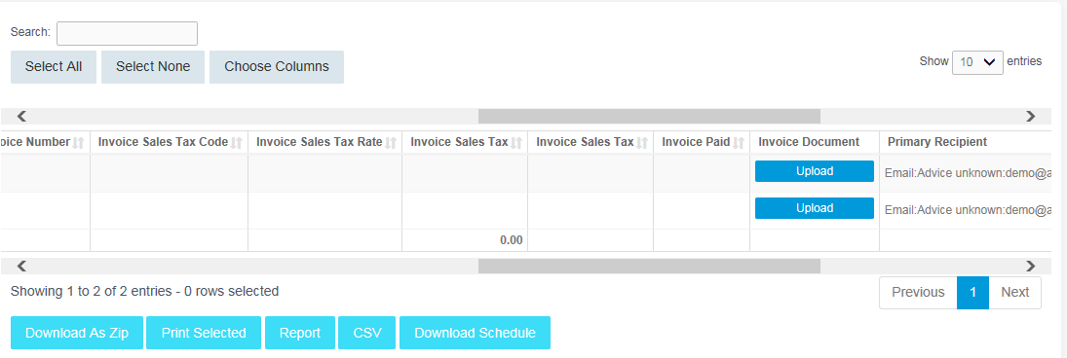
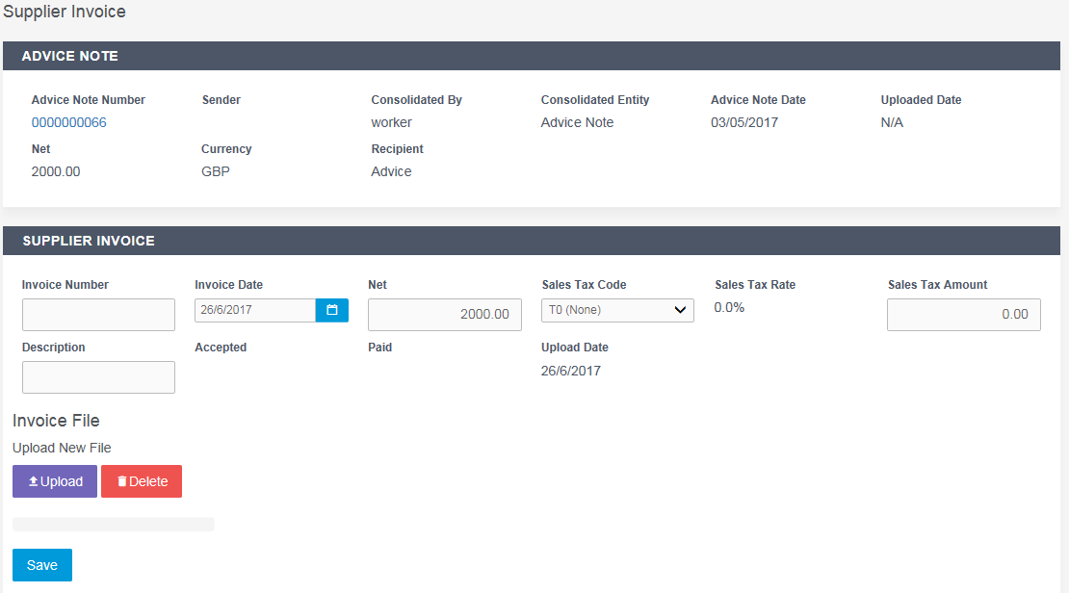

- In the Your Invoice Number field, enter your own invoice reference.
- In the Your Invoice Date field, set the date of your invoice.
- The Net field is prep-populated with the amount from the advice note.
- The Sales Tax Code field is pre-populated with the information from the placement.
- The Sales Tax Amount is pre-populated based on the Net and Sales Tax Code fields.
- If required, enter a description for the invoice.
- Click Upload to search for the invoice on your computer click open and it will automatically upload.
- When the file is uploaded, a purple line appears across the screen.
Image 8
- Click Save and the Invoice details are saved.

Contract documents
If dashboards are enabled within the agency client portal, contract documents and information requests can be viewed by clicking the relevant item within the contract documents activity dashboard. Alternatively you can use the Compliance option on the menu bar. To view your assigned documents, click view in the last column of the document list.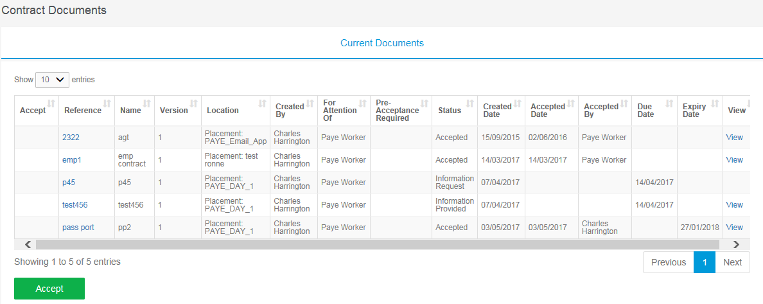
To accept the document, click on the reference which will direct you to an actions area where you can change the status. Click Confirm Action to accept the document and submit a file.
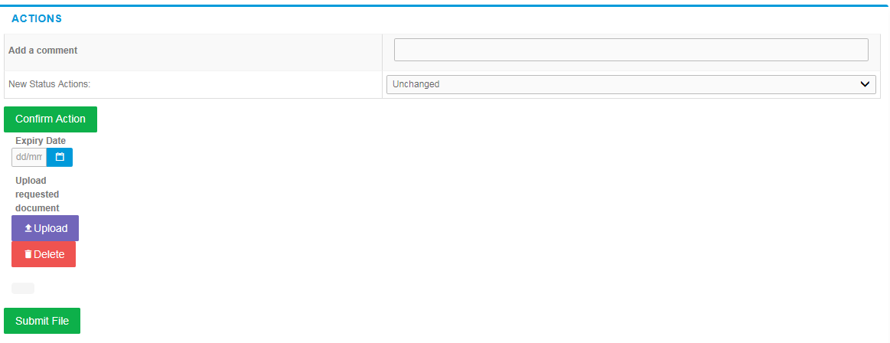

Viewing profile information
There are two types of profile information available, they are:

- Select Clients from the Profiles menu, this provides details relating to all clients who you are assigned to.

- Select Placements from the Profiles menu, this will provide you a list of all active placements that you are responsible for. You can obtain more information relating to the placement by clicking on details report. This will show all details such as the agency, Worker, Manager and Consultant associated with the placement as well as any reference codes, start and finish dates, job descriptions and contract documents.

